LOST DOG

Please Help Find

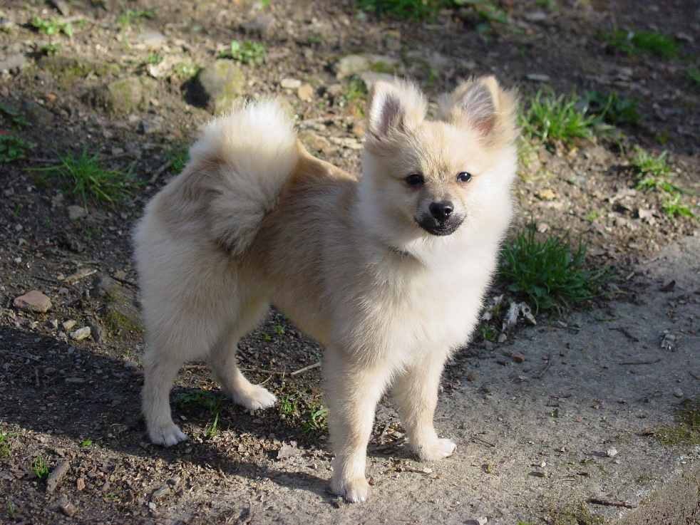

Beloved family dog has run away. Last seen Saturday on 8/16/16. Appearance of dog is exactly the same as picture above and he responds to the name Benji.

Please call Brian King, (718)613-6207, if you spot or have this dog.

**$100 REWARD**

Help Please